Schedule

# Tasks Break-down

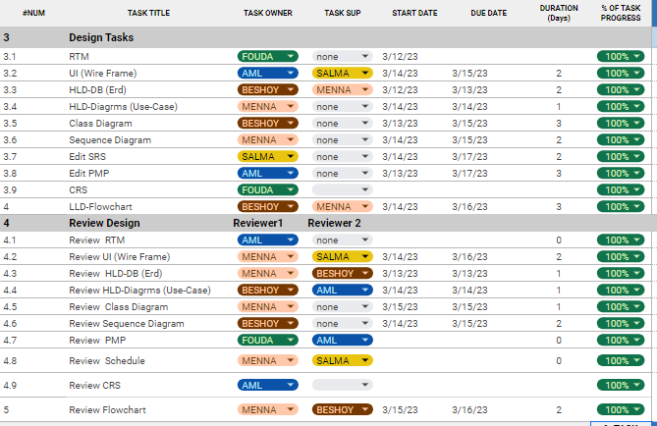

**Daily Tracking for Tasks**

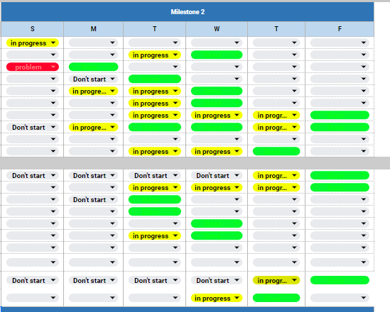

# Meeting Minutes

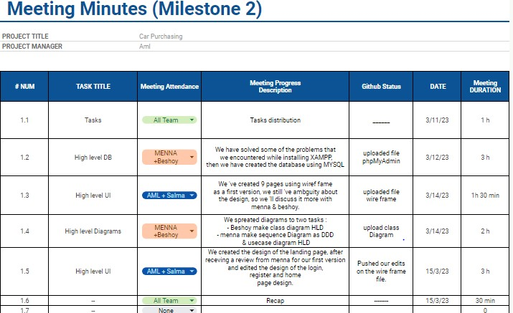

**Responsibilities**

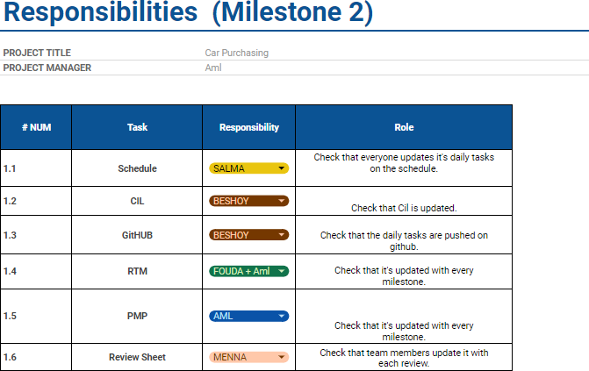

Schedule link: [https://docs.google.com/spreadsheets/d/1hhN_ZLge-](https://docs.google.com/spreadsheets/d/1hhN_ZLge-2vv8D7oXlERcaKGV2LPPn2G9jOTQHw3TqY/edit#gid%3D1115838130) [2vv8D7oXlERcaKGV2LPPn2G9jOTQHw3TqY/edit#gid=1115838130](https://docs.google.com/spreadsheets/d/1hhN_ZLge-2vv8D7oXlERcaKGV2LPPn2G9jOTQHw3TqY/edit#gid%3D1115838130)